Dear Parents & Students
Welcome to 4th grade at Mission Crest Elementary School! We are looking forward to the 2016-2017 school year and meeting all of you! To help make this year a success for our 4th graders, below, you will find a suggested supply list for your student. Your donation of these items would be greatly appreciated. See you soon!
1 box of 12 black whiteboard markers
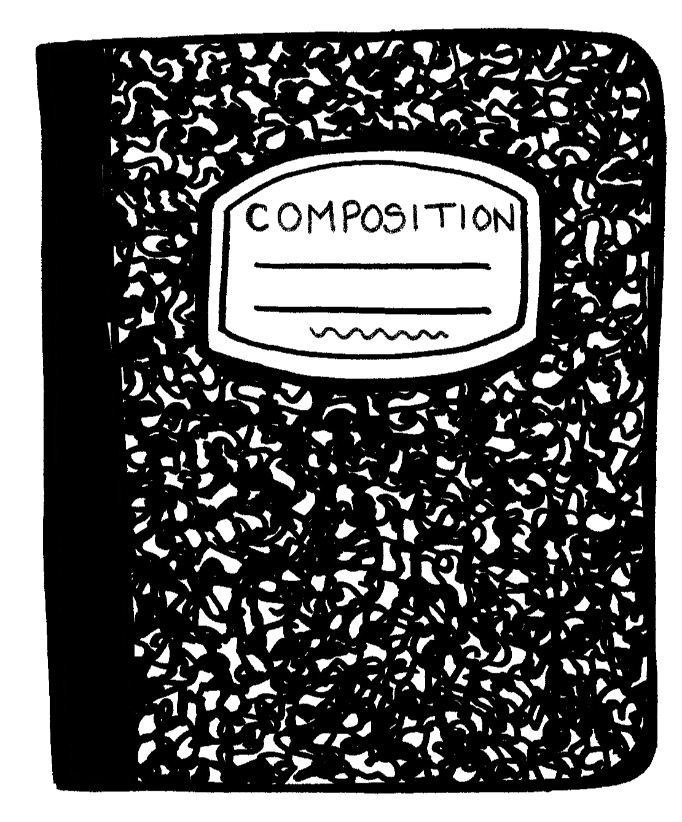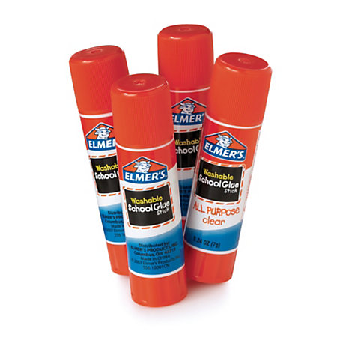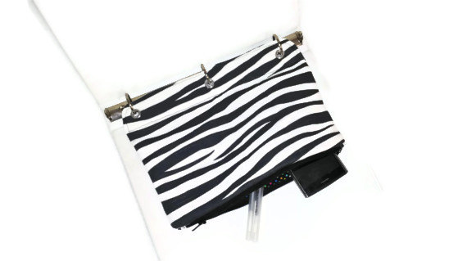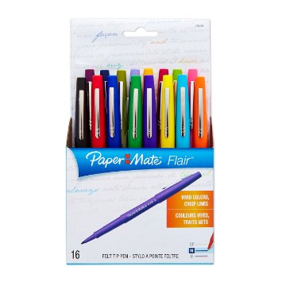
1 nylon pencil pouch (Please, no boxes)
3 hardcover composition books (preferred) OR
3 spiral one-subject notebooks
1 box of Dixon pencils
1 multi-color pack of highlighters (not gel)
1 pack of 12-24 fine tip markers
1 pair of children’s scissors
3 glue sticks & 1 glue bottle (Elmers is best)
1 plain 3 ring binder – 1 inch only
(please do not send a huge binder with pockets and pouches. They don’t fit inside of their desk!)

**Many of these supplies may need to be replenished when we return from Winter Break in January.
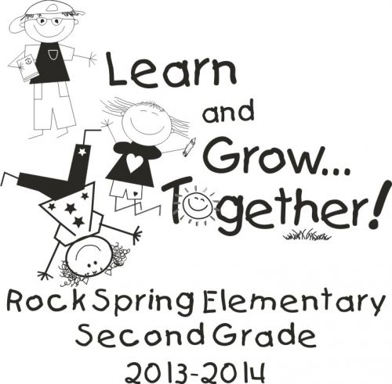

Remember, school starts on Monday August 8, 2016. We are excited to meet you and your child and to start off the school year with a bang!
Sincerely,
Mission Crest’s 4th Grade Team

